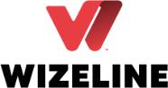

**Global Referral Program Policy**

Wizeline Employees



|  |  |
| --- | --- |
| **Document Owner** | Wizeline |
|  |  |
| **Revision** | 3 |
|  |  |
| **Last Updated** | January 26th, 2021 |
|  |  |
| **Owner** | Ana Landeros, Sarai Gutierrez |
|  |  |
| **Collaborators** | Rick Vega, Hugo Lopez, Karina Garcia |
|  |  |

Copyright © 2022 Wizeline All rights reserved.

Privileged or confdential information may be contained in this document and may be subject to legal privilege. Access to this document by anyone other than the intended is unauthorized. The content of this document is for informational purposes and subject to change without notice. No part of this publication may be reproduced, stored, or distributed without prior written permission of Wizeline.





**Purpose**

Our people are the key element in Wizeline’s success and why we are the secret weapon of global enterprises and trusted allies of high-growth startups.

We employ consistent practices to recruit and retain the best talent across the U.S., Latin America, Spain, and Asia Pacifc. Every candidate goes through a rigorous interview process, which includes a full day of on-site evaluation with technical challenges. We only hire the top 2% of candidates because we truly understand what it means to be a good engineer.

Therefore, we would like to expedite the process for those referrals you would love to work with -- people with excellent talent and culture ft that would complement your team and be amazing additions to our community.

On the following pages, you’ll fnd more information about how our referral program works, the ways you can beneft from it, and the different programs we have for you.

**Audience**

Wizeline Employees



**Page 2** • 2021 Wizeline - [Referral Program] All Rights Reserved INTERNAL ONLY - DO NOT DISTRIBUTE



**Contents**

|  |  |
| --- | --- |
| **Purpose** | **2** |
| **Guidelines of the Program** | **4** |
| Your role as a referrer | 4 |
| Eligibility guidelines | 4 |
| Non-eligible participants | 4 |
| Non-eligible referrals | 4 |
| Multiple referrals | 5 |
| Submitting a Referral | 5 |
| **Referral Programs** | **6** |
| Workfow of the Standard Program | 7 |
| Workfow of the Golden Pass Program | 7 |
| Approvers and approval fow | 8 |
| Workfow of the External Program | 8 |
| Other Considerations | 10 |



**Page 3** • 2021 Wizeline - [Referral Program] All Rights Reserved INTERNAL ONLY - DO NOT DISTRIBUTE



**Guidelines of the Program**

**Your role as a referrer**

As a member of our team, you’re the best ambassador to spread the word about Wizeline and our culture. Your network is Wizeline’s best source of talent, and when you refer a candidate, you become one of our most valuable assets to grow the team.

**A referral is:**

* A friend, former co-worker, acquaintance or industry peer who you would recommend and endorse for employment at Wizeline, who fts an open job position. If your referral is a relative, or you participate in the hiring process (interviews), your Technology Program Lead must be notifed, so they can make adjustments to the process if needed to avoid a confict of interest.

**Eligibility guidelines**

* You must be a full-time Wizeline employee.
* All referrals must be offcially submitted through [Greenhouse](https://wizeline.greenhouse.io/) (no exceptions).
* Only referrals who have not yet begun the screening and interview process.
* Referral must be hired directly by Wizeline.
* Candidates from another country where we have a local entity for hiring.
* Both the referrer and the new hire must be active on Wizeline’s payroll at the time the bonus payout is scheduled.
* Referrals are valid for 3 months only for Americas and Asia and 6 months for Europe . If the same candidate becomes active again after this period through a new application, agency, sourcing, or a new referrer, the referral source will be updated. If a candidate is rejected after starting a selection process and then referred, the source will update, and thereby the latest referrer will be given the credit.

**Non-eligible participants**

* Directors, E-staff members are not eligible for rewards, but they can still refer. TA members are not eligible unless they refer someone for their own team and they do not participate in the hiring process.
* The referrer should not report to the referral in any case.
* Successful referrals made for the Engineering team will be rewarded only if a full-time employee is hired directly by Wizeline.



**Page 4** • 2021 Wizeline - [Referral Program] All Rights Reserved INTERNAL ONLY - DO NOT DISTRIBUTE





**Non-eligible referrals**

* Active Wizeline employees.
* Former Wizeline employees that left Wizeline for less than 12 months.
* Candidates sourced or currently enrolled (at Wizeline) from recruitment agencies and recruitment consultancies.

**Multiple referrals**

There may be situations in which the referred candidate has been referred by multiple employees. In those cases, the frst referral submitted to Greenhouse receives the bonus credit. If the candidate is submitted by a Wizeline employee and also by Talent Acquisition or a recruiting agency 3 months before the employee’s submission, the bonus will not apply. In this case, BizOps or the agency are committed to provide evidence of when the frst contact with the candidate was made.

**Submitting a Referral**

When adding a referral to GreenHouse, all referrals without exception need to include the following important information to avoid rejection of the referral:

* Complete Name.
* Candidate’s email address and phone number.
* LinkedIn profle and Resume.
* Notes that describe the candidate's experience.
* Selection of the program you are referring to.

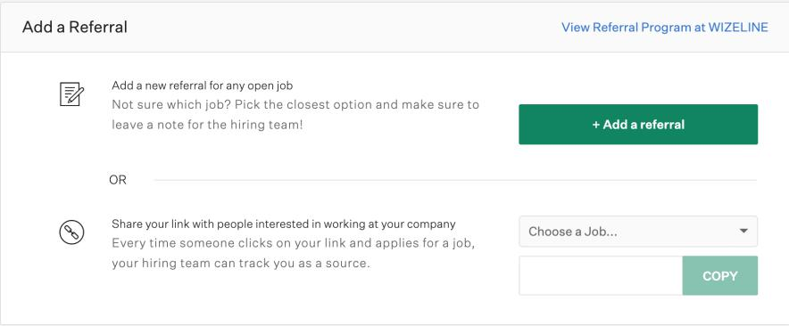

**Page 5** • 2021 Wizeline - [Referral Program] All Rights Reserved INTERNAL ONLY - DO NOT DISTRIBUTE



If any of the below information is missing the system could not be able to submit the referral properly. During the process, Greenhouse will keep the referrer updated with any progress.

**Pay Period:** In the next payroll 90 days after referral´s start date, **if they meet expectations of the position. In the case of referrals with Golden Pass, positive feedback is needed from their manager or program lead in order to pay the bonus. The performance and bonus payment will be confrmed by the BizOps team.**

**Referral Programs**

|  |  |  |  |
| --- | --- | --- | --- |
| **Referral** | **Who can refer?** | **Countries** | **Bonus** |
| **Program** |  |  |  |
|  |  |  |  |
| **Standard** | All full-time Wizeliners. | All | $1000 USD* |
|  |  |  |  |
| **Golden** | > 1 year Wizeliners. | All | $2000 USD* |
| **Pass** |  |  |  |
|  |  |  |  |
| **External** | Pre-qualifed candidates who are being | Mexico | $250 USD |
|  | interviewed and successfully passed a |  | Amazon gift |
|  | technical screen. Talent Ambassadors should |  | card** |
|  | communicate this program based on the |  |  |
|  | potential they see in the candidate’s network. |  |  |
|  |  |  |  |
| **Diversity** | All women referred | All | $500 USD |

***\*The amounts expressed are before taxes. The amounts of taxes taken out may vary depending on the country/state location.***

***\*\* Sent 1 week after your candidate accepts our offer.***

**Workfow of the Standard Program**

[Flow Chart Link](https://docs.google.com/presentation/d/1d-FFgsHYiFMuRxf9G2si0APoT4ZgmRJxxEBYpDOUkZQ/edit#slide=id.gdc20a27b51_0_1172)



**Page 6** • 2021 Wizeline - [Referral Program] All Rights Reserved INTERNAL ONLY - DO NOT DISTRIBUTE



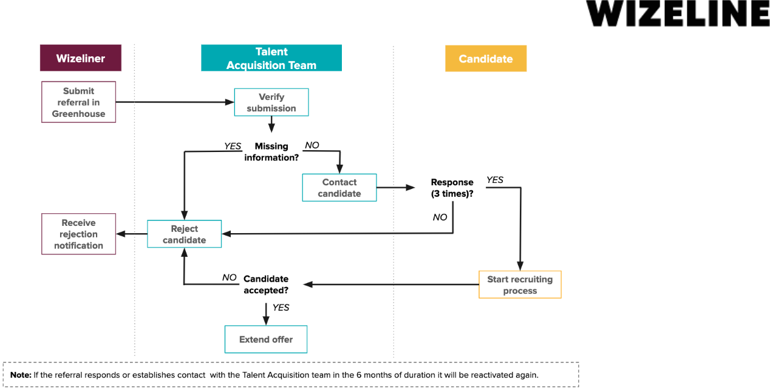

**Workfow of the Golden Pass Program**

[Flow Chart Link](https://docs.google.com/presentation/d/1Hmkd5E2M1Hc5SyPf7XRcbKwbfsrBQ-Se-t35WPd--nc/edit#slide=id.g103e40eef7c_0_157)

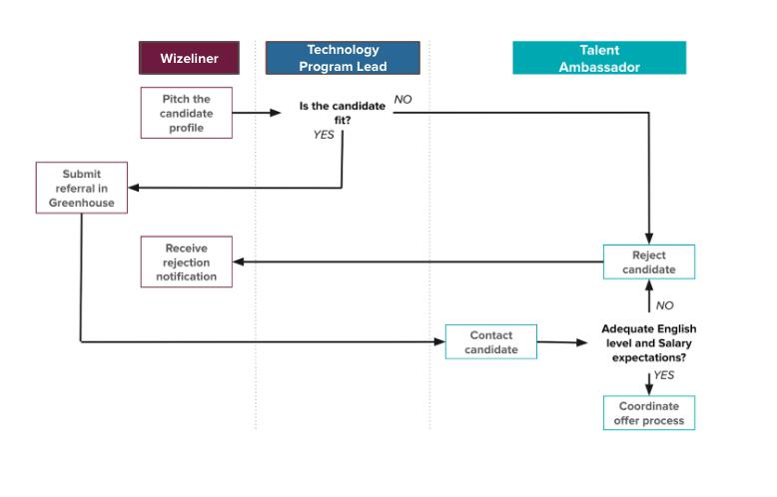

**Page 7** • 2021 Wizeline - [Referral Program] All Rights Reserved INTERNAL ONLY - DO NOT DISTRIBUTE





**Specifcations for Golden Pass Program:**

* Referral sent directly to the offer stage without a previous technical assessment or onsite.
* Not applicable for Directors positions.
* This pass will be given by the Technology Program Lead of the referral's program.
* If the candidate referred does not perform well during the 90 days of employment, you lose your Golden Pass and have to wait 18 months to get another one.
* The Technology Program Lead will evaluate the candidate based on several things:
  + Seniority. Ideally, people only use a Golden Pass with someone they know professionally and they know to be very experienced and would be a good addition to Wizeline.
  + The kind of projects the candidate has worked on, level of complexity, and relevance to the challenges we face at Wizeline.
* You will be held accountable for the new employee's performance during their frst 90 days at Wizeline. You will work closely with the new employee's manager to coach/mentor the new hire if needed.

**Approvers and approval fow**

The Technology Program Lead for the position is the only one that can approve your Golden pass. Our priority is to bring the best talent to Wizeline, so any situation not prevented in this policy will be reviewed by Engineering Directors.*Table 2 . This table only applies for the positions and program leads at Mexico

**Workfow of the External Program**

[Flow Chart Link](https://docs.google.com/presentation/d/1d-FFgsHYiFMuRxf9G2si0APoT4ZgmRJxxEBYpDOUkZQ/edit#slide=id.g103e40eef7c_0_157)



**Page 8** • 2021 Wizeline - [Referral Program] All Rights Reserved INTERNAL ONLY - DO NOT DISTRIBUTE



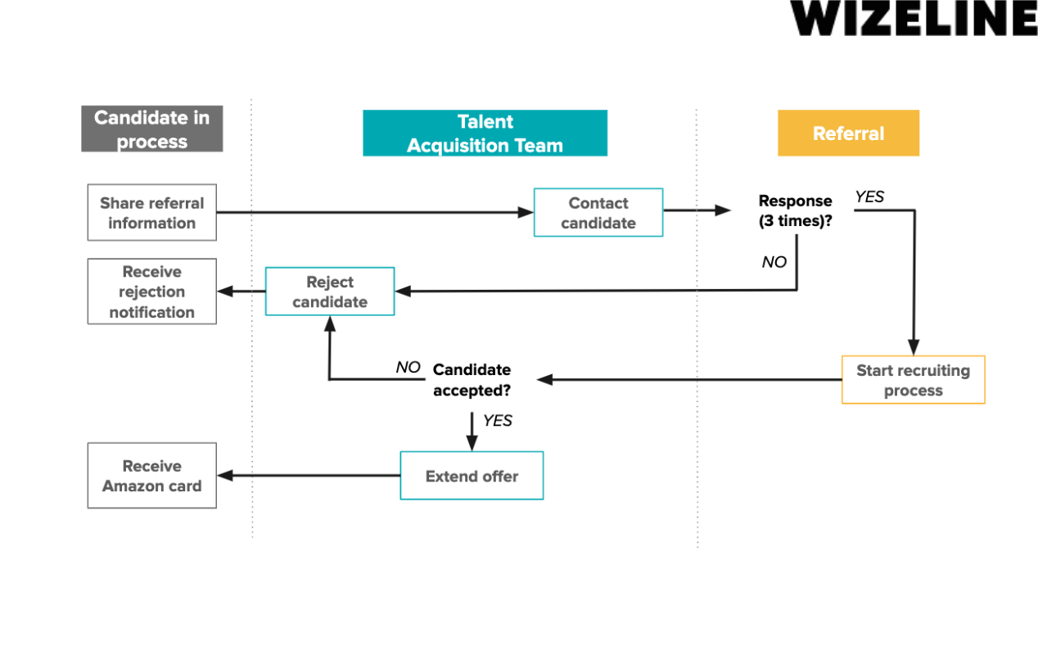

**Specifcations for External Program:**

For a referral to be considered as your lead you have to share by email with your Talent Ambassador:

1. Referral full name and email address
2. LinkedIn profle and/or resume, so that the Talent Acquisition Team can assess the candidate's experience.
3. Notes that describe the candidate's experience and how well you know each other.

**Other Considerations**

The decisions made in special cases are unique and will not be taken as a rule.

If a person is not eligible for this bonus at the time to receive the payment but was eligible at the time that the new hire was referred, the payment will be honored.

The referral bonus applies as usual for any referred Academy student hired up to 3 months after the course. For any student that applies after 3 months, it is necessary to refer them again.



**Page 9** • 2021 Wizeline - [Referral Program] All Rights Reserved INTERNAL ONLY - DO NOT DISTRIBUTE



All the referral candidates are a priority to the Talent Acquisition team, nevertheless their top priority is to fulfll the current demand, so we ask for your patience if your referral is taking more time than what you expect in a specifc stage. In case of any misunderstanding the TA’s Manager will decide on specifc situations.

Contractors are eligible as long as they appear in Bamboo.

**Wizeline reserves the right to modify, amend or terminate these programs at any time, for any reason.**



**Page 10** • 2021 Wizeline - [Referral Program] All Rights Reserved INTERNAL ONLY - DO NOT DISTRIBUTE

